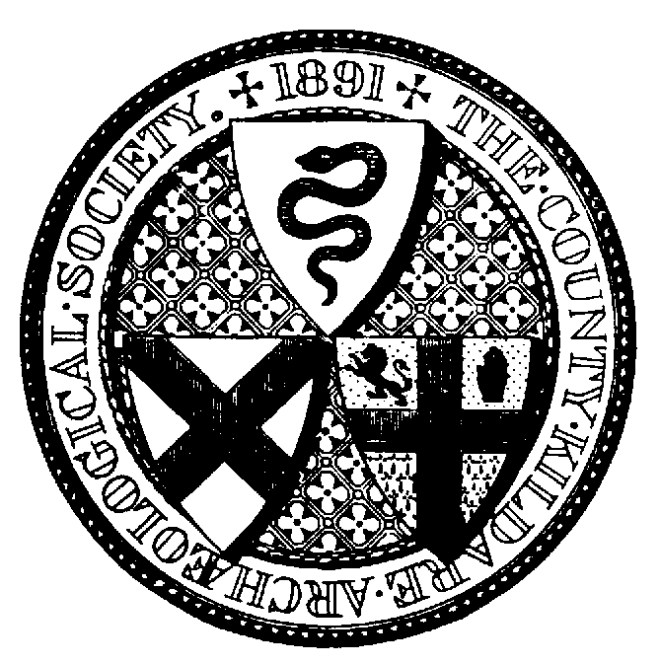

Sunday 6th July 2025 - 11.30pm ( Picnic @12:00 noon)
Annual Excursion to Monksgrange House, Rathnure, Enniscorthy, Co Wexford by courtesy of Mr. Jeremy Hill
Booking Form (Members only)

Name ___________________________________________________________

Address _________________________________________________________

________________________________ Eircode _________________________

Mobile no:____________________ email:______________________________

Cost: €25 (includes tea/coffee)

Visit: ______ place/s I enclose payment of € _______

Please note that early booking is essential as places are limited.

Please send cheques or manual payments and booking form, with copy of SEPA payment if applicable to Honorary Secretary by 28th June 2025. Cheques should be made out to ‘County Kildare Archaeological Society’. For SEPA Credit Transfers, please include your name in narrative.

IBAN IE10 AIBK 9335 0302 3241 54 BIC Code: AIBK IE2D.

County Kildare Archaeological Society

Honorary Secretary
Siobhán McNulty
83 The Elms
NEWBRIDGE
Co Kildare
W12 XT20
087 6879221

