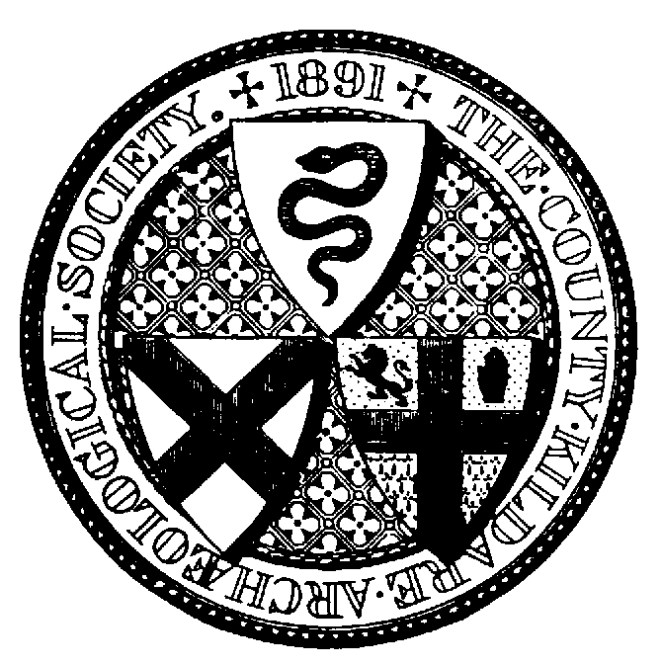

Launch of the 2023 CKAS Journal Vol XXIV
Venue: Clanard Court Hotel, Athy
Saturday 21 October at 7.00pm

Booking Form (Members and their guests)

Name ___________________________________________________________

Address _________________________________________________________

________________________________ Eircode _________________________

Mobile no:____________________ email:______________________________

Dinner: _______ place/s @ €39 per person

I enclose payment of € _______

Please send cheques or manual payments and booking form, with copy of SEPA payment if applicable, to Elizabeth Connelly at the above address.

Cheques should be made out to ‘County Kildare Archaeological Society’. For SEPA Credit Transfers, in narrative please state ‘Dinner’ followed by your name. IBAN IE10 AIBK 9335 0302 3241 54 BIC Code: AIBK IE2D.

County Kildare Archaeological Society

Elizabeth Connelly
Newington House
Christianstown
Newbridge, Co Kildare
W12 TW60
Tel: 083 8620101

